84,78,77,70

1) CREATE TABLE IF NOT EXISTS EMPTABLE

(

Empid NUMERIC(6) PRIMARY KEY,

Name VARCHAR(10) NOT NULL,

City VARCHAR(10),

DOB DATE NOT NULL,

Sex CHARACTER(1),

DOJ DATE NOT NULL,

Salary NUMERIC(8, 2),

Department VARCHAR(10),

CONSTRAINT Name_Check CHECK (ASCII(LEFT(Name, 1)) BETWEEN ASCII('A') AND ASCII('Z')),

CONSTRAINT City_Check CHECK (ASCII(LEFT(City, 1)) BETWEEN ASCII('A') AND ASCII('Z')),

CONSTRAINT Sex_Check CHECK (Sex in ('M', 'F')),

CONSTRAINT Salary_Check CHECK (Salary BETWEEN 15000 AND 50000),

CONSTRAINT Department_Check CHECK (Department in ('ACC', 'FIN', 'EDP'))

);

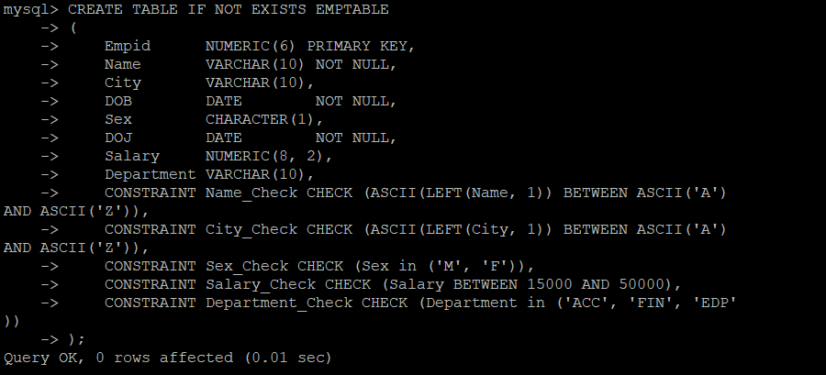

2) INSERT INTO EMPTABLE VALUES (1001, 'Anish', 'Chennai', STR_TO_DATE('21-apr-1966', '%d-%b-%Y'), 'M', STR_TO_DATE('10-jun-1986', '%d-%b-%Y'),17000, 'ACC'),

(1002, 'Anandi', 'Ooty', STR_TO_DATE('11-sep-1975', '%d-%b-%Y'), 'F', STR_TO_DATE('17-jun-1997', '%d-%b-%Y'), 15000, 'FIN'),

(1003, 'Shiva', 'Kambam', STR_TO_DATE('07-feb-1966', '%d-%b-%Y'), 'M', STR_TO_DATE('21-apr-1991', '%d-%b-%Y'), 21000, 'EDP'),

(1004, 'Deepa', 'Trichi', STR_TO_DATE('14-feb-1967', '%d-%b-%Y'), 'M', STR_TO_DATE('21-apr-1990', '%d-%b-%Y'),15000, 'FIN'),

(1005, 'Engela', NULL, STR_TO_DATE('23-mar-1970', '%d-%b-%Y'), 'F', STR_TO_DATE('21-apr-1986', '%d-%b-%Y'),32000, 'EDP'),

(1006, 'Krish', 'Trichi', STR_TO_DATE('14-jul-1970', '%d-%b-%Y'), 'F', STR_TO_DATE('21-mar-1989', '%d-%b-%Y'),15000, 'ACC'),

(1007, 'Kamal', 'Ooty', STR_TO_DATE('14-jul-1966', '%d-%b-%Y'), 'M', STR_TO_DATE('04-mar-1990', '%d-%b-%Y'),15000,'FIN'),

(1008, 'Neela', 'Madurai', STR_TO_DATE('27-jun-1969', '%d-%b-%Y'), 'F', STR_TO_DATE('07-apr-1990', '%d-%b-%Y'), 25000, 'EDP'),

(1009, 'Bala', 'Coimbatore', STR_TO_DATE('29-oct-1962', '%d-%b-%Y'), 'M', STR_TO_DATE('21-apr-1993', '%d-%b-%Y'),20000, 'ACC'),

(1010, 'Rajesh', 'Pollachi', STR_TO_DATE('21-apr-1966', '%d-%b-%Y'), 'M', STR_TO_DATE('12-oct-1993', '%d-%b-%Y'),17000, 'FIN'),

(1011, 'Rekha', 'Coimbatore', STR_TO_DATE('21-apr-1970', '%d-%b-%Y'), 'F',

STR_TO_DATE('14-dec-1999', '%d-%b-%Y'),20000, 'ACC'),

(1012, 'Xavier', 'Madurai', STR_TO_DATE('21-apr-1971', '%d-%b-%Y'), 'M', STR_TO_DATE('12-mar-1997', '%d-%b-%Y'),20000, 'ACC'),

(1013, 'Vinotha', 'Trichi', STR_TO_DATE('21-apr-1972', '%d-%b-%Y'), 'F', STR_TO_DATE('21-apr-1994', '%d-%b-%Y'),17000, 'ACC');

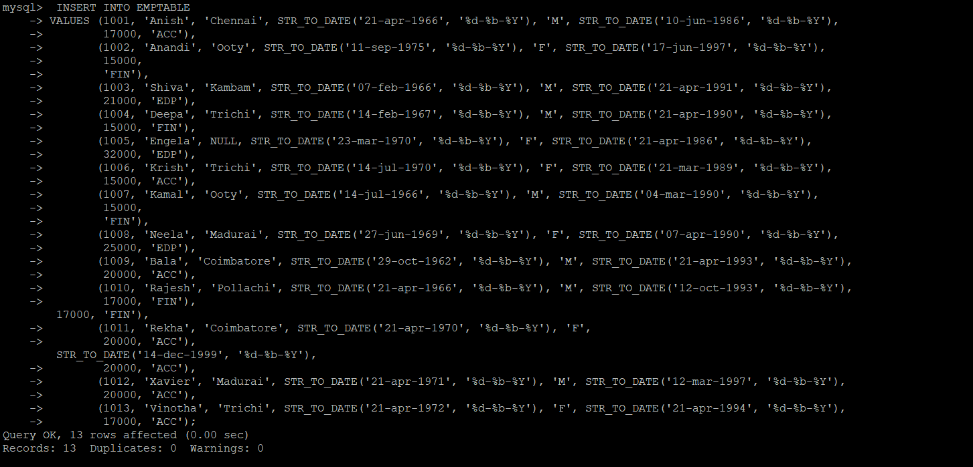

3)i) SELECT *

FROM EMPTABLE;

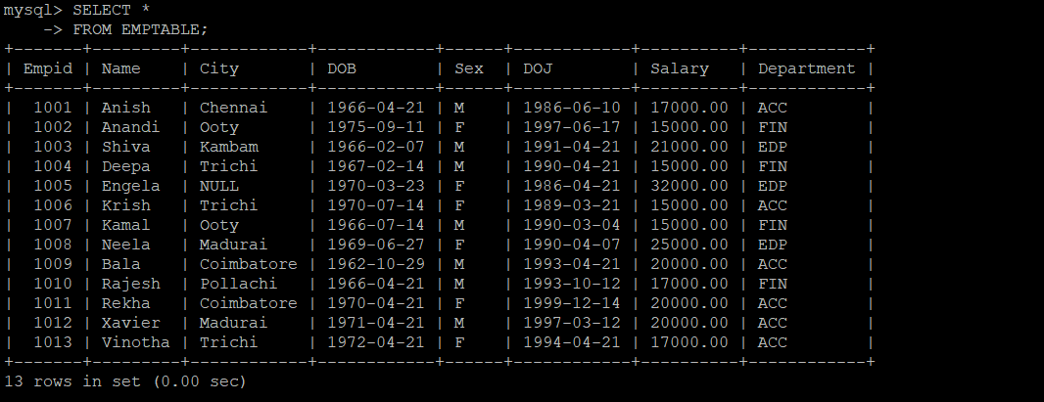

ii) SELECT Empid, Name, City, Salary

FROM EMPTABLE;

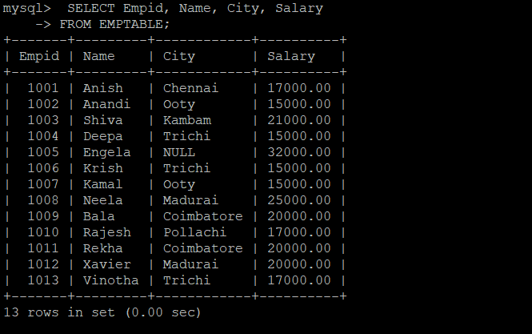

iii)SELECT *

FROM EMPTABLE

WHERE Name = 'Bala';

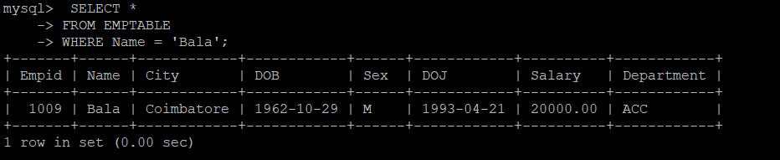

iv) SELECT *

FROM EMPTABLE

WHERE Sex = 'M';

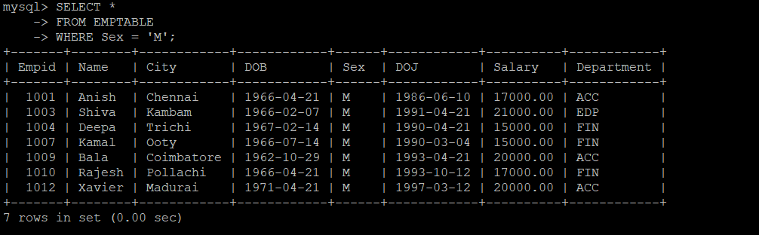

v)SELECT *

FROM EMPTABLE

WHERE City = 'Coimbatore';

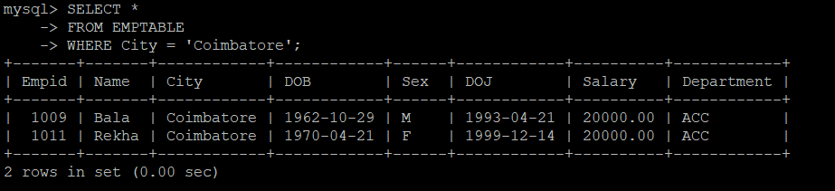

vi)SELECT *

FROM EMPTABLE

WHERE City IN ('Coimbatore', 'Trichi', 'Chennai');

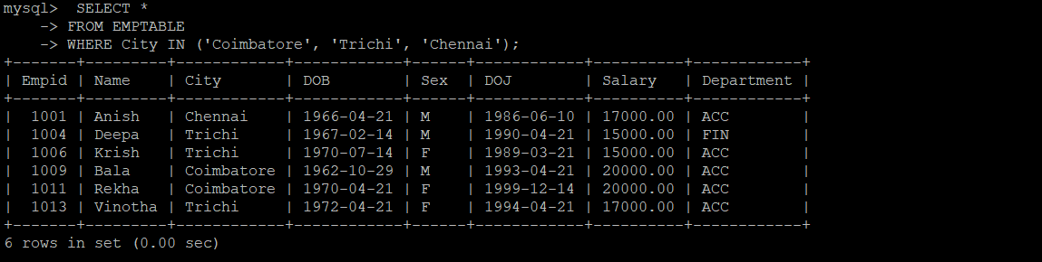

vii) SELECT Name

FROM EMPTABLE

WHERE City IS NULL;

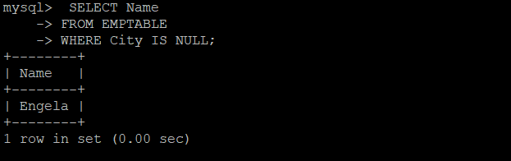

viii) SELECT DISTINCT City

FROM EMPTABLE;

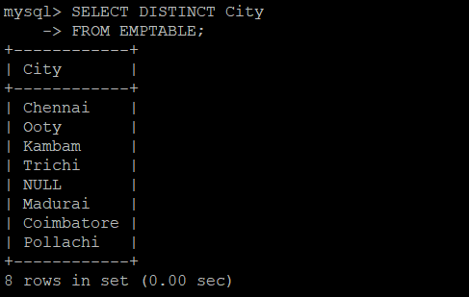

ix) SELECT Empid, Salary * 2

FROM EMPTABLE;

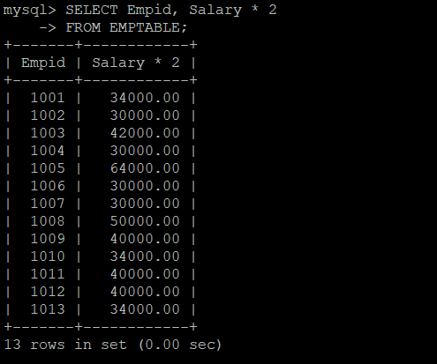

x)SELECT Name, City

FROM EMPTABLE

WHERE Salary > 50000;

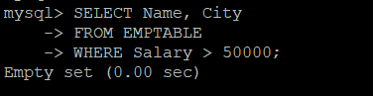

xi) SELECT Empid, Name, Salary * 1.05 AS 'Increased Salary'

FROM EMPTABLE;

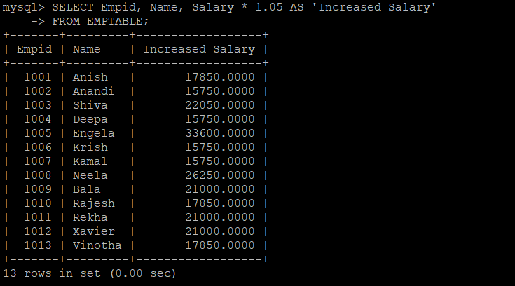

xii) SELECT Empid, Name, Salary * 1.05 AS 'Increased Salary'

FROM EMPTABLE

ORDER BY `Increased Salary` DESC;

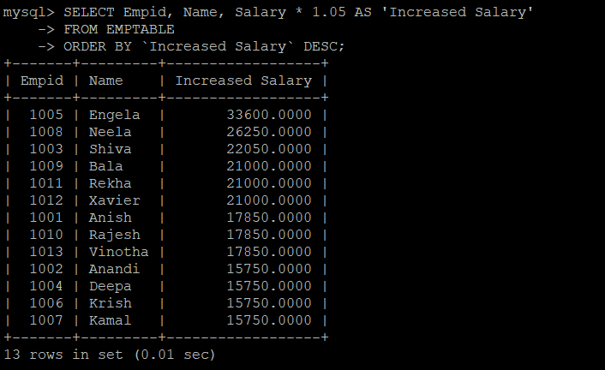

xiii)SELECT *

FROM EMPTABLE

ORDER BY Name, Salary DESC;

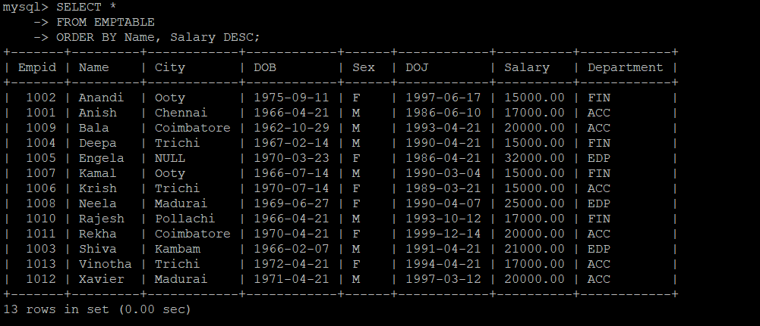

xiv) SELECT COUNT(*)

FROM EMPTABLE;

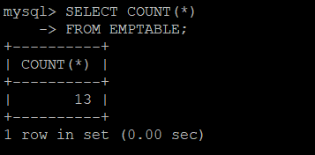

xv) SELECT DISTINCT COUNT(Department)

FROM EMPTABLE;

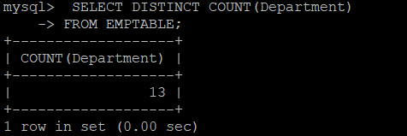

xvi) SELECT COUNT(*)

FROM EMPTABLE

WHERE Department = 'FIN';

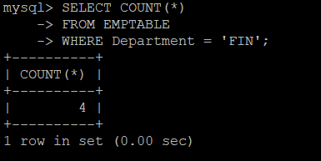

xvii) SELECT COUNT(*)

FROM EMPTABLE

WHERE Sex = 'M';

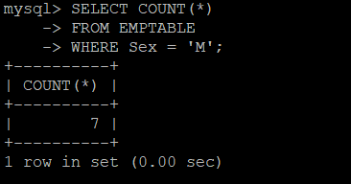

xviii)SELECT Name

FROM EMPTABLE

WHERE Salary = (SELECT MAX(Salary) FROM EMPTABLE);

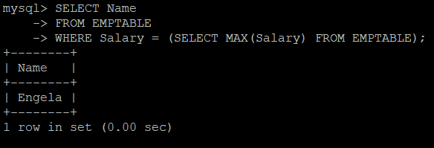

xix)SELECT Name

FROM EMPTABLE

WHERE Salary = (SELECT MIN(Salary) FROM EMPTABLE);

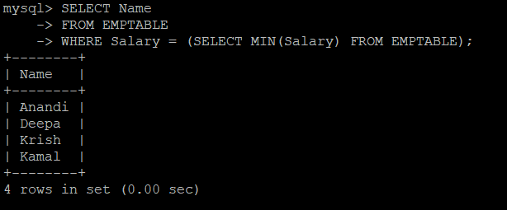

xx) SELECT Department, SUM(Salary)

FROM EMPTABLE

GROUP BY Department;

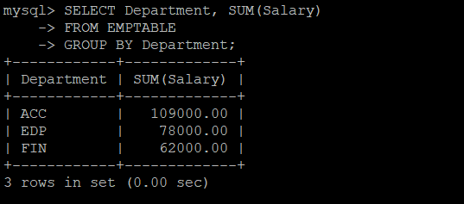

xxi) SELECT Empid

FROM EMPTABLE

WHERE Empid != 1002;

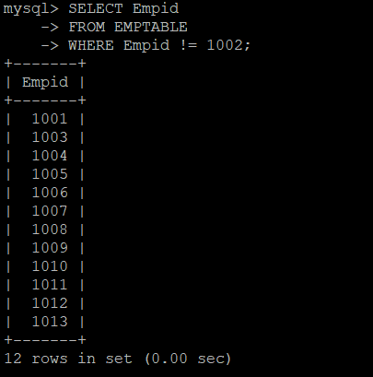

xxii) SELECT *

FROM EMPTABLE

WHERE ASCII(LEFT(Name, 1)) = ASCII('A');

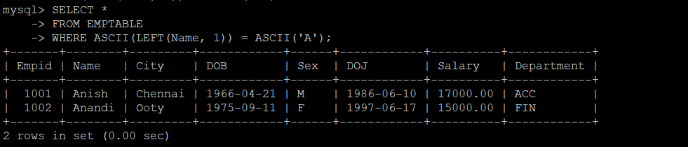

xxiii) SELECT *

FROM EMPTABLE

WHERE DOB < DATE(STR_TO_DATE('01-jan-91', '%d-%b-%y'));

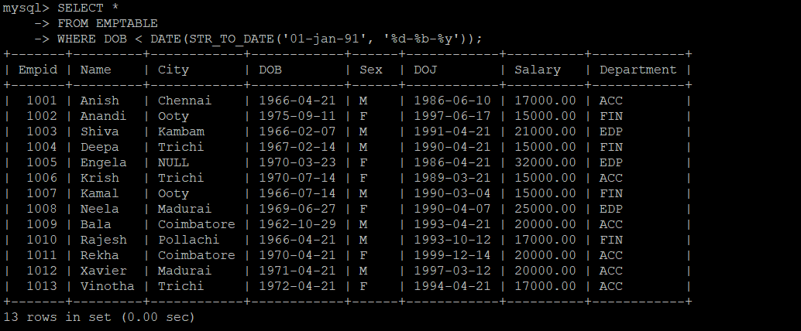

xxiv) SELECT Name

FROM EMPTABLE

WHERE Salary BETWEEN 20000 AND 40000;

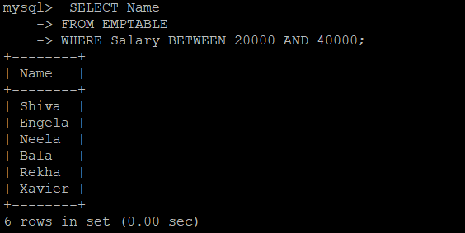

xxv)SELECT *

FROM EMPTABLE

WHERE Salary > 20000;

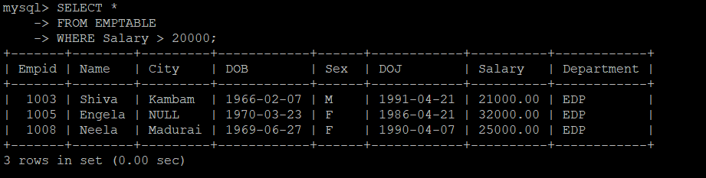

xxvi) SELECT *

FROM EMPTABLE

WHERE Salary > 20000

AND Department = 'ACC';

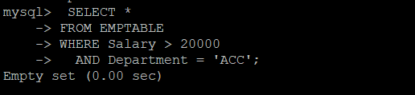

xxvii) SELECT *

FROM EMPTABLE

WHERE Salary > 20000;

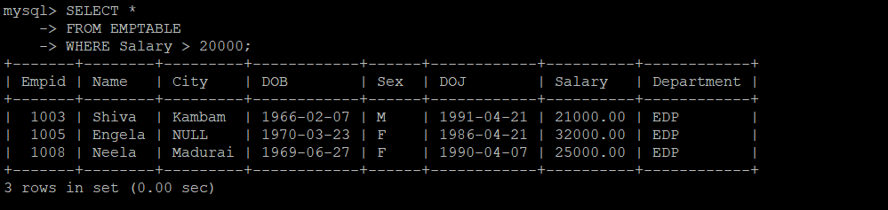

xxviii) SELECT NAME, SALARY, DEPARTMENT

FROM EMPTABLE

WHERE SALARY IN (SELECT MIN(SALARY) FROM EMPTABLE GROUP BY DEPARTMENT);

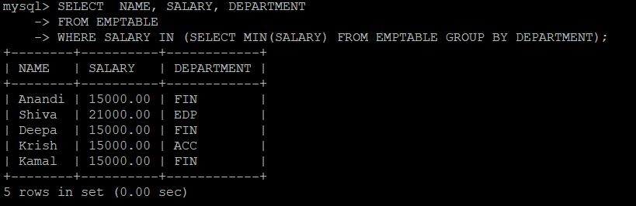

xxix)SELECT Department, COUNT(*)

FROM EMPTABLE

WHERE Sex = 'M'

GROUP BY Department;

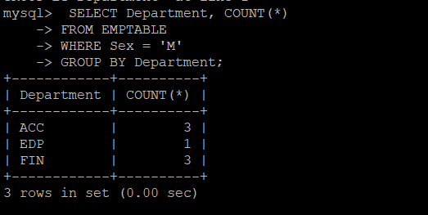

xxx) SELECT DEPARTMENT, MIN(SALARY), MAX(SALARY), SUM(SALARY), AVG(SALARY)

FROM EMPTABLE

GROUP BY DEPARTMENT;

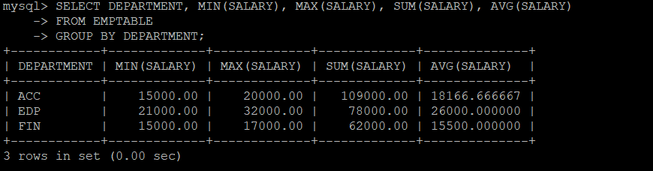

31) SELECT TIMESTAMPDIFF(DAY, DOJ, CURRENT_TIMESTAMP)

FROM EMPTABLE;

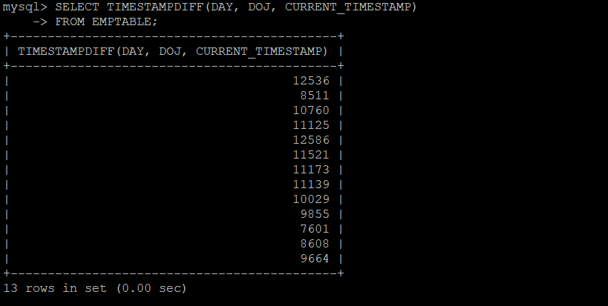

32) SELECT TIMESTAMPDIFF(YEAR, DOJ, CURRENT_TIMESTAMP)

FROM EMPTABLE;

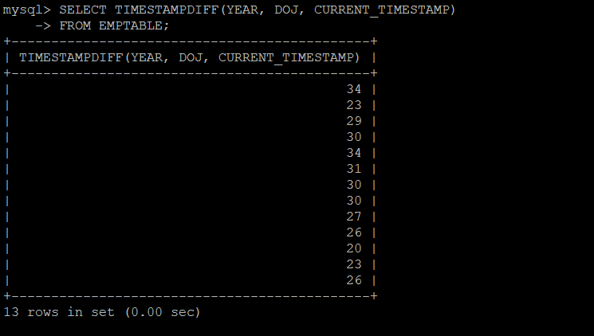

33) SELECT NAME, TIMESTAMPDIFF(YEAR, DOB, CURRENT_TIMESTAMP) AS 'AGE'

FROM EMPTABLE;

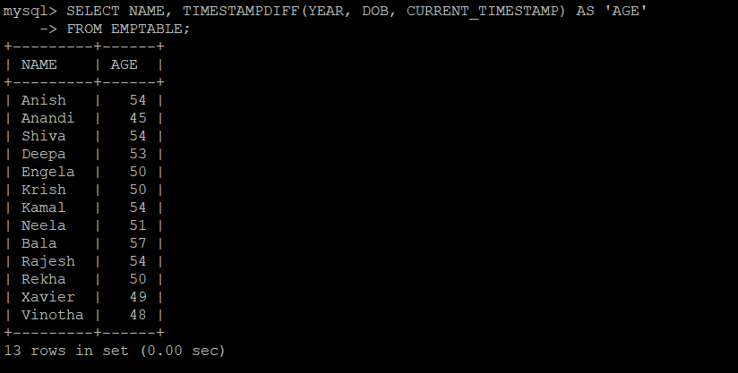

34) SELECT NAME

FROM EMPTABLE

WHERE DOB = (SELECT MIN(DOB) FROM EMPTABLE);

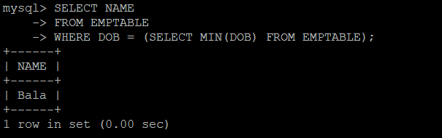

35) SELECT TIMESTAMPDIFF(YEAR, DOb, CURRENT_TIMESTAMP) AS 'AGE'

FROM EMPTABLE

WHERE DOB = (SELECT MIN(DOB) FROM EMPTABLE);

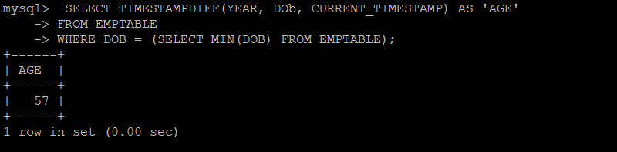

36) SELECT Name, City

FROM EMPTABLE

ORDER BY Name, City;

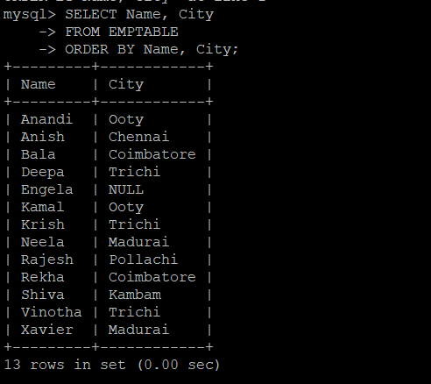

37)SELECT Name, DOB

FROM EMPTABLE

WHERE MONTH(DOB) = '01';

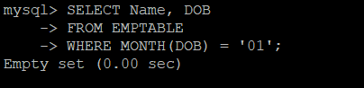

38)SELECT Department, COUNT(*)

FROM EMPTABLE

GROUP BY Department;

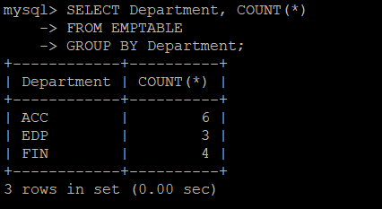

39)SELECT Sex, AVG(TIMESTAMPDIFF(YEAR, DOB, CURRENT_TIMESTAMP))

FROM EMPTABLE

GROUP BY Sex;

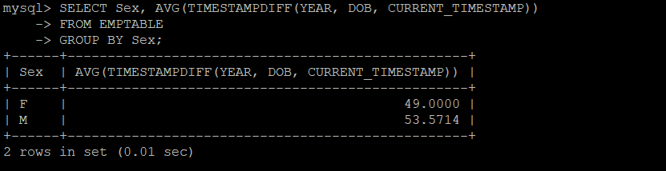

40) SELECT Name, DOB

FROM EMPTABLE

WHERE MONTH(DOB) = MONTH(CURDATE());

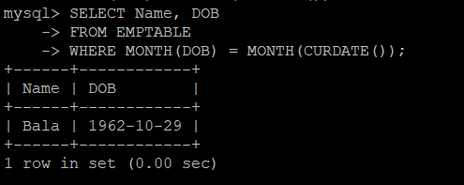

41) SELECT AVG(Salary)

FROM EMPTABLE;

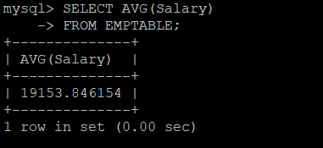

42) SELECT Department, AVG(Salary)

FROM EMPTABLE

GROUP BY Department;

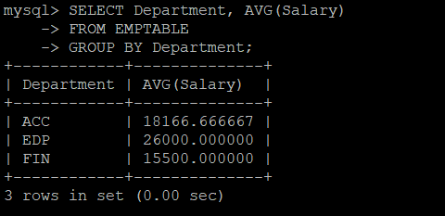

43)SELECT Department, SUM(Salary)

FROM EMPTABLE

GROUP BY Department;

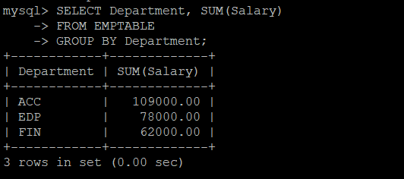

44) SELECT COUNT(*)

FROM EMPTABLE

WHERE Salary > 30000;

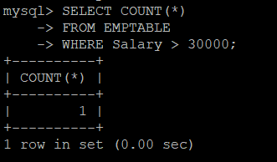

45) SELECT MAX(Salary)

FROM EMPTABLE;

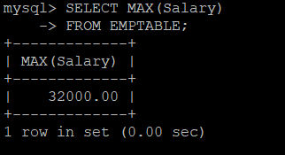

46)SELECT Department, MAX(Salary)

FROM EMPTABLE

GROUP BY Department;

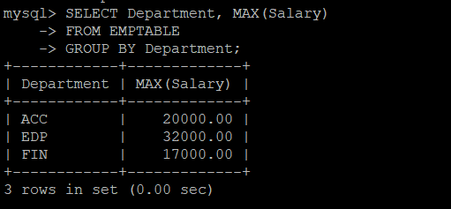

47)SELECT COUNT(*)

FROM EMPTABLE

WHERE City = 'Coimbatore'

AND Sex = 'F';

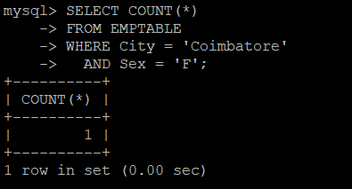

48) SELECT *

FROM EMPTABLE

WHERE MONTH(DOB) NOT IN (3, 10);

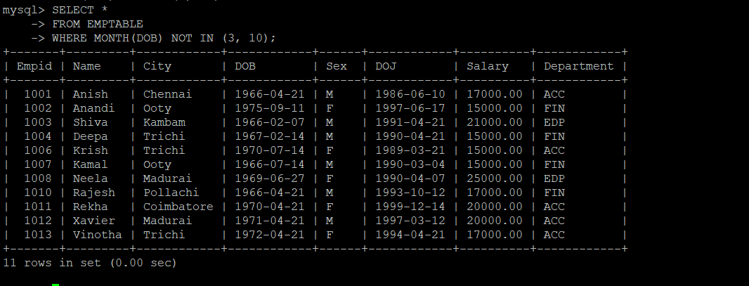

49) SELECT Department, COUNT(*) AS 'Female Employees'

FROM EMPTABLE

WHERE Sex = 'F'

GROUP BY Department;

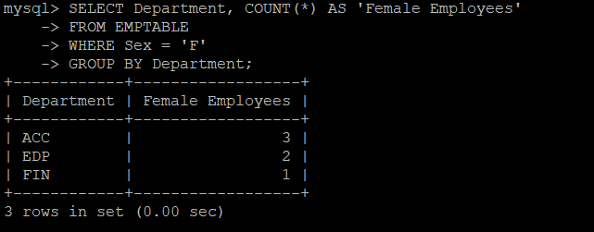

50) SELECT Name, City, DOB

FROM EMPTABLE;

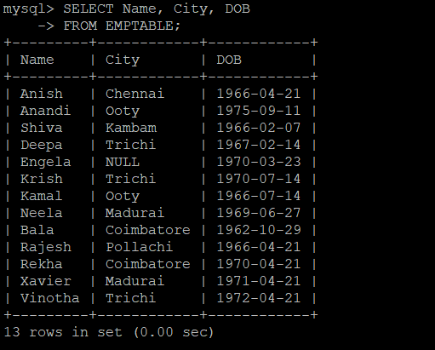

51) SELECT MAX(Salary) - MIN(Salary) AS Difference

FROM EMPTABLE;

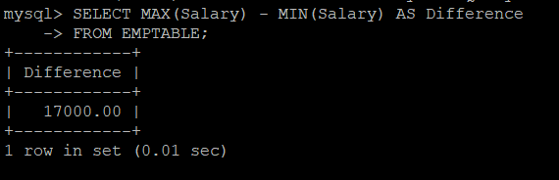

52) SELECT Department

FROM EMPTABLE

GROUP BY Department

ORDER BY COUNT(Department) DESC

LIMIT 1;

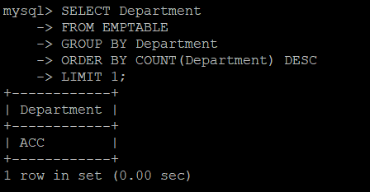

53) SELECT Department

FROM EMPTABLE

GROUP BY Department

ORDER BY COUNT(*)

LIMIT 1;

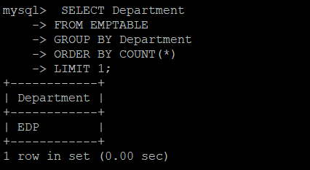

54)SELECT Name

FROM EMPTABLE

WHERE DOB = (SELECT DOB FROM EMPTABLE WHERE YEAR(DOB) = 1990 AND Sex = 'F' ORDER BY DOB DESC LIMIT 1);



55)SELECT Name

FROM EMPTABLE

WHERE DOB = (SELECT DOB FROM EMPTABLE WHERE YEAR(DOB) = 1990 AND Sex = 'F' ORDER BY DOB DESC LIMIT 1);



56) SELECT Name

FROM EMPTABLE

WHERE TIMESTAMPDIFF(YEAR, DOB, CURRENT_TIMESTAMP) < 32;

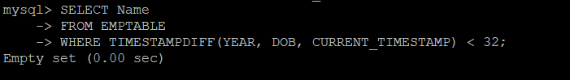

57) SELECT Name

FROM EMPTABLE

WHERE TIMESTAMPDIFF(YEAR, DOB, CURRENT_TIMESTAMP) <

(SELECT TIMESTAMPDIFF(YEAR, DOB, CURRENT_TIMESTAMP) FROM EMPTABLE WHERE Empid = 1007);

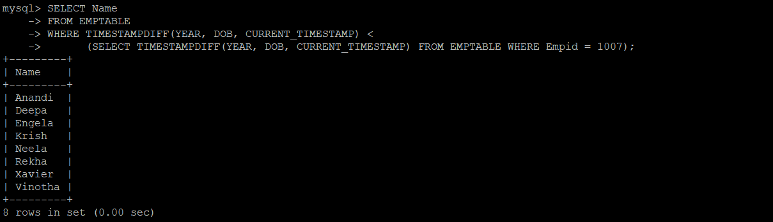

58) SELECT YEAR(DOB)

FROM EMPTABLE

GROUP BY YEAR(DOB)

ORDER BY COUNT(DOB) DESC

LIMIT 1;

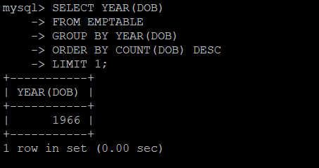

59) SELECT MONTH(DOB)

FROM EMPTABLE

GROUP BY MONTH(DOB)

ORDER BY COUNT(DOB) DESC

LIMIT 1;

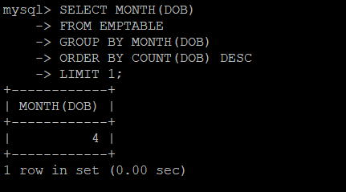

60)SELECT Name

FROM EMPTABLE

WHERE Sex = 'M'

AND Salary < (SELECT AVG(Salary) FROM EMPTABLE WHERE Sex = 'F');

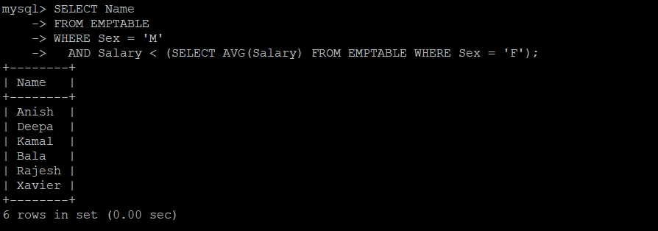

61)SELECT *

FROM EMPTABLE

WHERE Salary IN (SELECT Salary FROM EMPTABLE GROUP BY Salary HAVING COUNT(Salary) > 1);

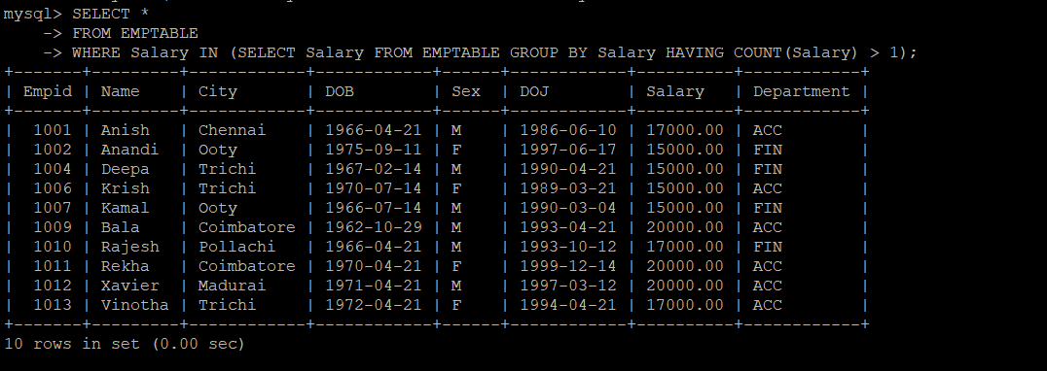

62) SELECT COUNT(DISTINCT DEPARTMENT) FROM EMPTABLE;

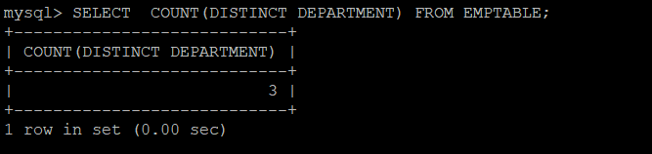

63) SELECT *

FROM EMPTABLE

WHERE LENGTH(NAME) <= 5;

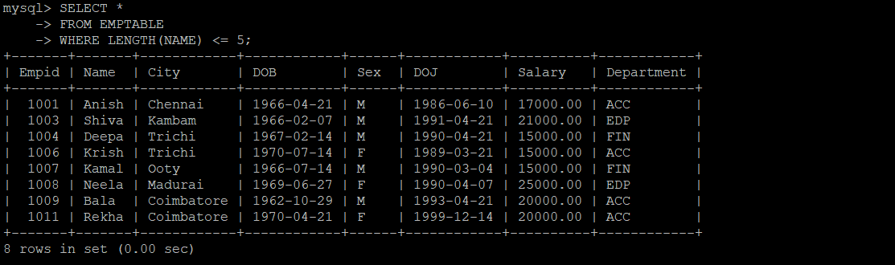

64) SELECT Name

FROM EMPTABLE

WHERE Name LIKE '%e%';

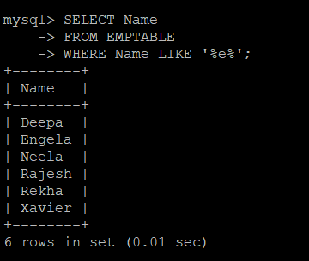

65) SELECT *

FROM EMPTABLE

WHERE City = 'Trichi'

AND Department IN

(SELECT Department FROM EMPTABLE WHERE City = 'Trichi' GROUP BY Department HAVING COUNT(Department) = 1);

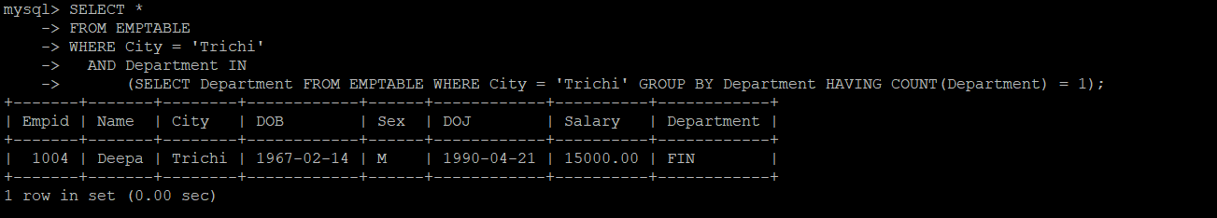

66) SELECT *

FROM EMPTABLE

ORDER BY City;

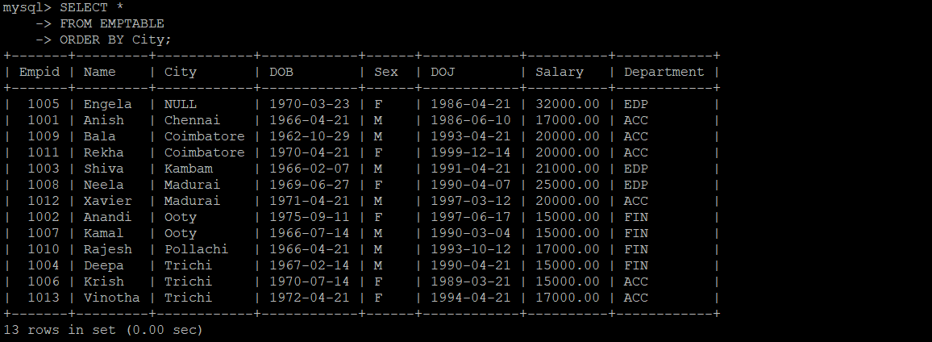

67) SELECT CITY, COUNT(*)

FROM EMPTABLE

GROUP BY CITY ;

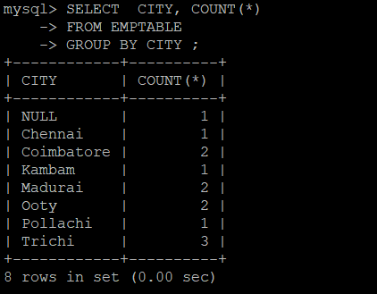

68) SELECT *

FROM EMPTABLE

WHERE (City, Salary) IN

(SELECT City, Salary FROM EMPTABLE GROUP BY City, Salary HAVING COUNT(Salary) > 1 AND COUNT(City) > 1);

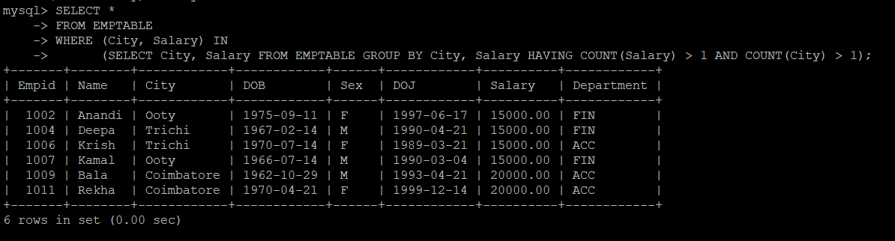

69)SELECT DISTINCT Department

FROM EMPTABLE

WHERE Department NOT IN (SELECT DISTINCT Department FROM EMPTABLE WHERE City = 'Trichi');

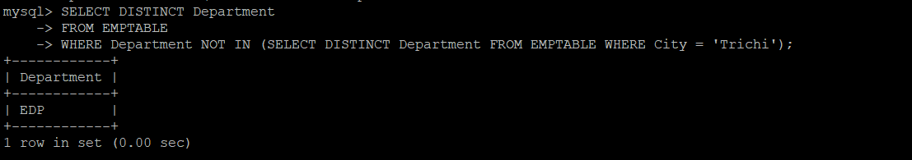

70) SELECT *

FROM EMPTABLE

WHERE Salary IN

(SELECT Salary

FROM EMPTABLE

GROUP BY Salary

HAVING COUNT(DISTINCT (Department)) > 1

AND COUNT(Department) = COUNT(DISTINCT (Department)));

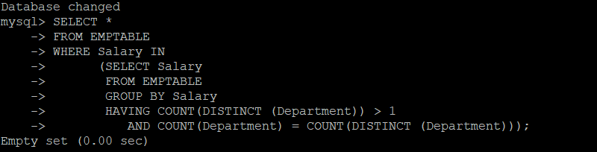

71) SELECT *

FROM EMPTABLE

WHERE Sex = 'F'

AND Salary IN (SELECT Salary FROM EMPTABLE GROUP BY Salary HAVING COUNT(Salary) > 1);

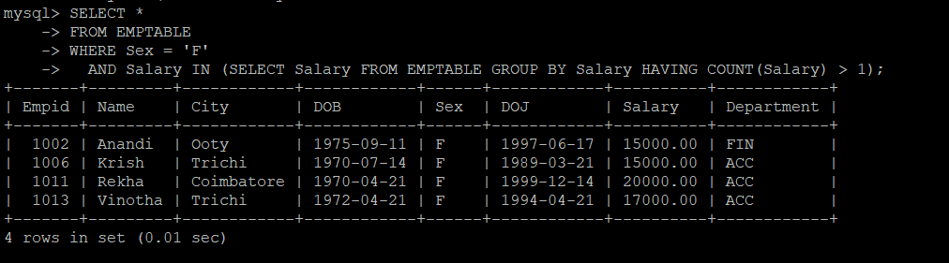

72) ALTER TABLE EMPTABLE

MODIFY COLUMN Name VARCHAR(15) NOT NULL;

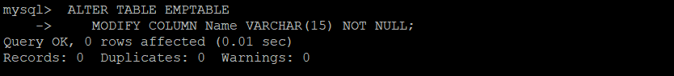

73) ALTER TABLE EMPTABLE

ADD COLUMN Age NUMERIC(3);



74) UPDATE EMPTABLE

SET Age = TIMESTAMPDIFF(YEAR, DOB, CURRENT_TIMESTAMP);

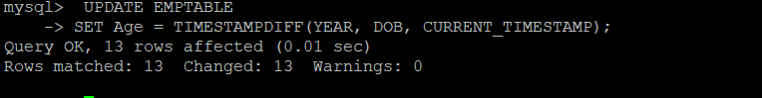

75) ALTER TABLE EMPTABLE

CHANGE DOB DateOfBirth DATE NOT NULL;



76) ALTER TABLE EMPTABLE

DROP COLUMN Age;

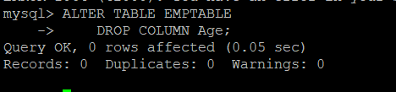

77) SELECT CONCAT(Name, ' of ', Department, ' department comes from ', City)

FROM EMPTABLE;

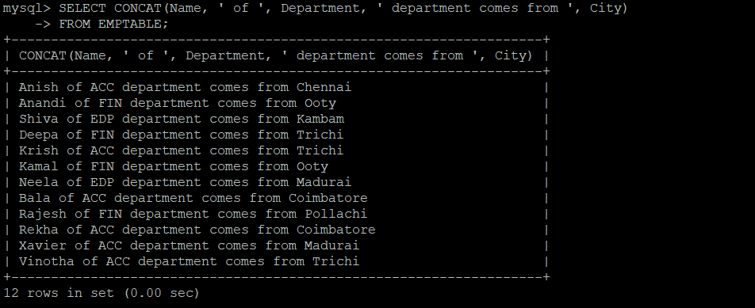

78) SELECT Name

FROM EMPTABLE

WHERE Department = 'ACC'

ORDER BY 1 DESC;

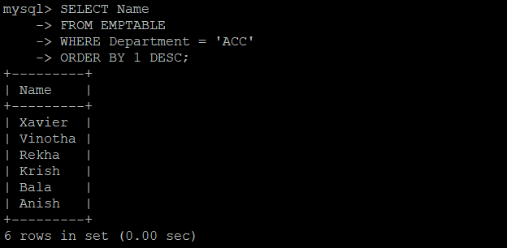

79) ALTER TABLE EMPTABLE

MODIFY COLUMN DOJ DATE;

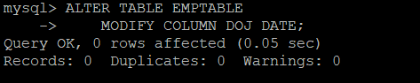

80)SELECT UPPER(Name), UPPER(City)

FROM EMPTABLE;

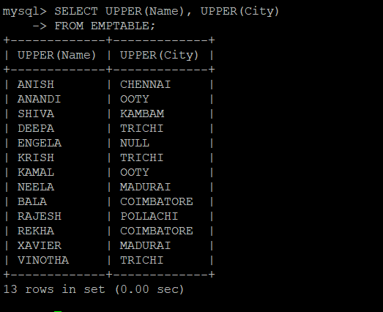

81)SELECT MONTH(DateOfBirth)

FROM EMPTABLE

GROUP BY MONTH(DateOfBirth)

ORDER BY COUNT(DateOfBirth) DESC

LIMIT 1;

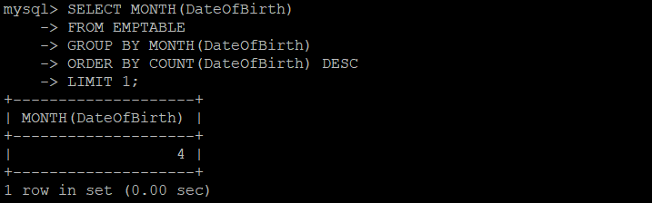

82)SELECT Name

FROM EMPTABLE

WHERE Sex = 'M'

AND Salary < (SELECT AVG(Salary) FROM EMPTABLE WHERE Sex = 'F');

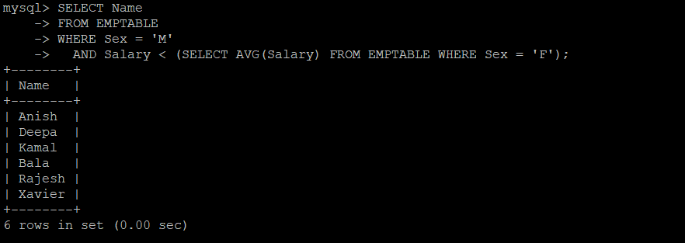

83) SELECT Name

FROM EMPTABLE

WHERE Sex = 'F'

AND Salary > (SELECT MAX(Salary) FROM EMPTABLE WHERE Sex = 'M');

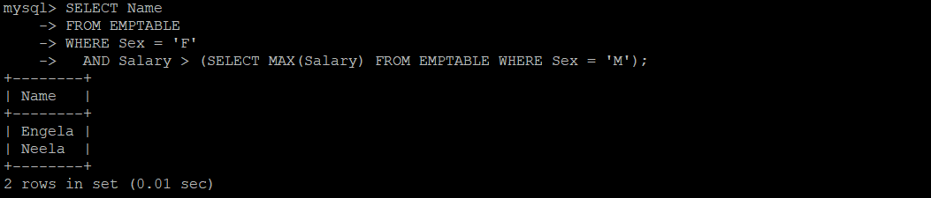

84)insert into EMPTABLE value ('1003', 'Sam', 'Erode', '1972-06-24', 'M', '1997-01-30', '60000', 'EDP');

85) DELETE

FROM EMPTABLE

WHERE Name = 'Engela';

